**_________________________________________________________**

**ELECTRICITY**

**ELECTROMOTER POWER SOURCE (FEM OR VOLTAGE SOURCE).**

**OPENING ACTIVITY 1. Based on your experience with the "turning on a focus" experiment, answer the following:**

1) Define with your words the concept of electric circuit

2) List the elements of a circuit based on your knowledge

3) How many types of circuits do you know?

4) List at least 3 household items where a resistance is used.

**DEVELOPMENT Activity 6. Make a conceptual map referring to electromotors power source ohm's law where you specify the types of circuits**

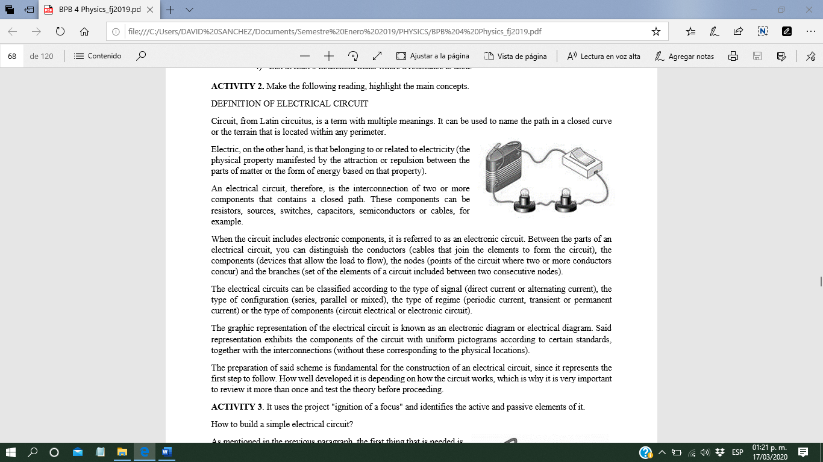**DEFINITION OF ELECTRICAL CIRCUIT**

Circuit, from Latin circuits, is a term with multiple meanings. It can be used to name the path in a closed curve or the terrain that is located within any perimeter.

Electric, on the other hand, is that belonging to or related to electricity (the physical property manifested by the attraction or repulsion between the parts of matter or the form of energy based on that property).

An electrical circuit, therefore, is the interconnection of two or more components that contains a closed path. These components can be resistors, sources, switches, capacitors, semiconductors or cables, for example.

When the circuit includes electronic components, it is referred to as an electronic circuit. Between the parts of an electrical circuit, you can distinguish the conductors (cables that join the elements to form the circuit), the components (devices that allow the load to flow), the nodes (points of the circuit where two or more conductors concur) and the branches (set of the elements of a circuit included between two consecutive nodes).

The electrical circuits can be classified according to the type of signal (direct current or alternating current), the type of configuration (series, parallel or mixed), the type of regime (periodic current, transient or permanent current) or the type of components (circuit electrical or electronic circuit).

The graphic representation of the electrical circuit is known as an electronic diagram or electrical diagram. Said representation exhibits the components of the circuit with uniform pictograms according to certain standards, together with the interconnections (without these corresponding to the physical locations).

The preparation of said scheme is fundamental for the construction of an electrical circuit, since it represents the first step to follow. How well developed it is depending on how the circuit works, which is why it is very important to review it more than once and test the theory before proceeding.

**Active and Passive Elements of the Electric Circuit**

The elements that make up an electrical circuit can be:

Active elements: devices capable of generating a voltage or a current and supplying energy to a given load.

Passive elements: those that in the current circular produce a potential difference between their terminals consuming These elements can also be taken as:

- Active elements voltage and current have the same sign.

- Passive elements voltage and current have different sign (example: a source charging).

An example of a passive element would be the resistor and the sources of current and voltage would be active elements. The capacitors and inductors are usually within these two categories because they absorb energy when it is charged and also supply energy when they are discharged.

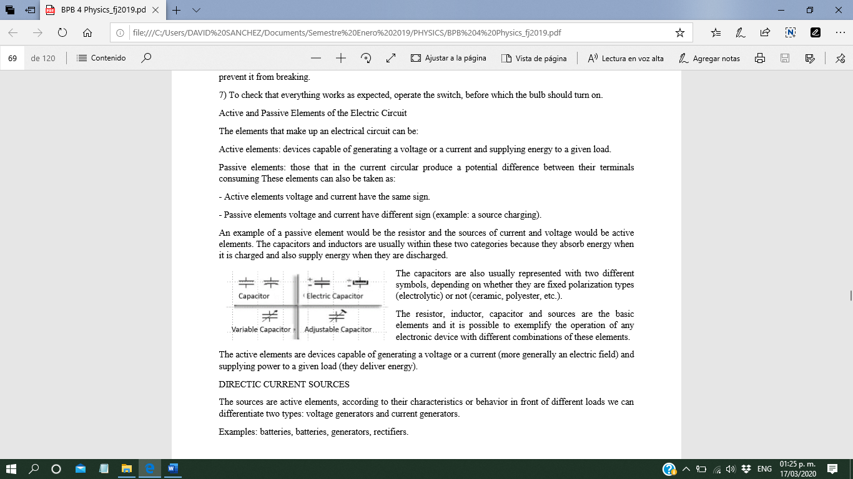The capacitors are also usually represented with two different symbols, depending on whether they are fixed polarization types (electrolytic) or not (ceramic, polyester, etc.).

The resistor, inductor, capacitor and sources are the basic elements and it is possible to exemplify the operation of any electronic device with different combinations of these elements.

The active elements are devices capable of generating a voltage or a current (more generally an electric field) and supplying power to a given load (they deliver energy).

DIRECTIC CURRENT SOURCES

The sources are active elements, according to their characteristics or behavior in front of different loads we can differentiate two types: voltage generators and current generators.

Examples: batteries, batteries, generators, rectifiers.

PASSIVE ELEMENTS

Those that consume or store energy.

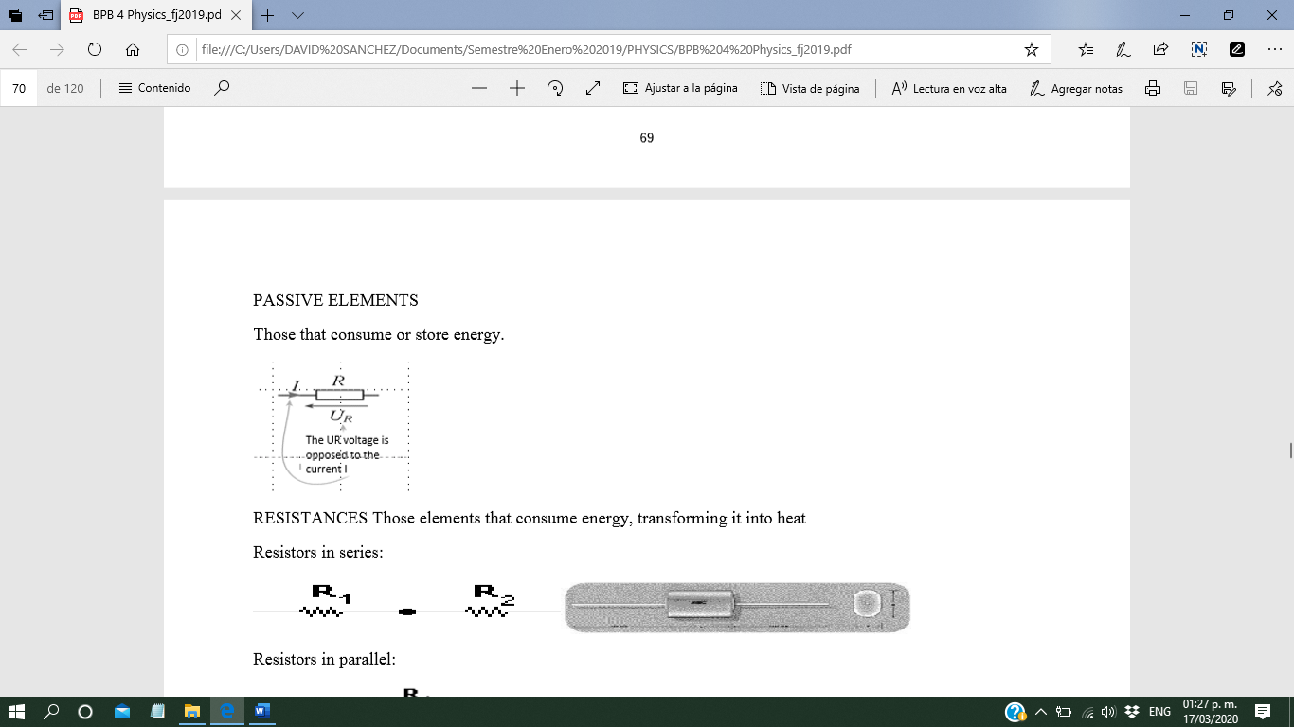

RESISTANCES

Those elements that consume energy, transforming it into heat

Resistors in series:

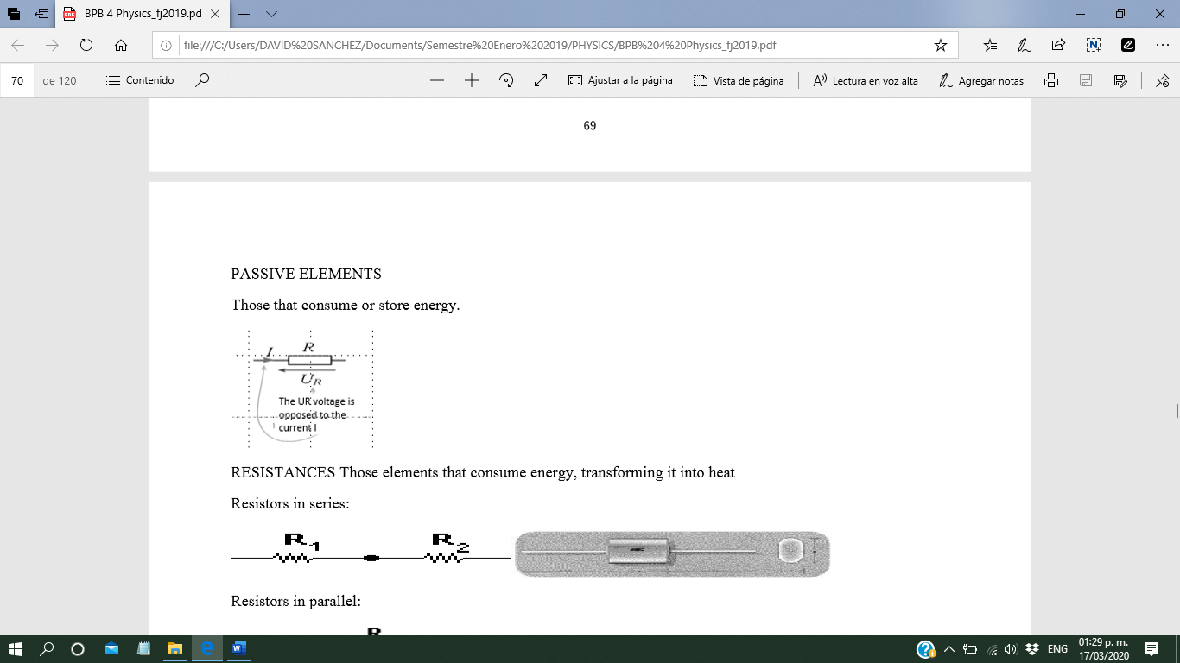

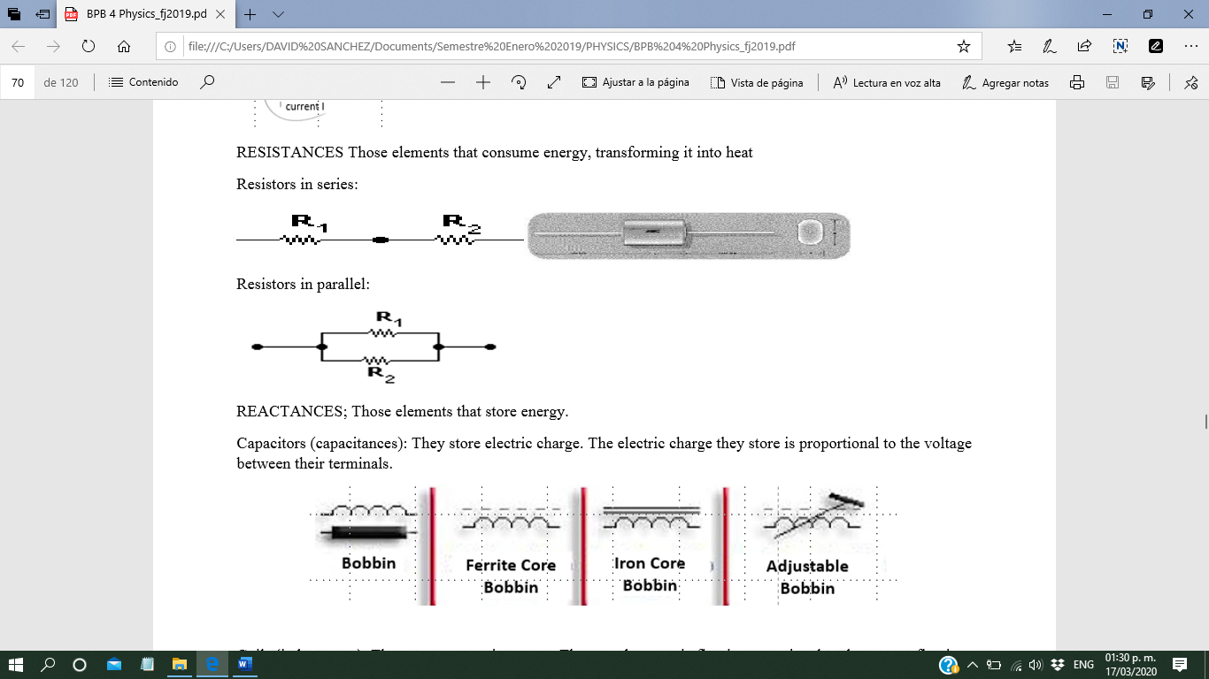

Resistors in parallel:

REACTANCES; Those elements that store energy. Capacitors (capacitances): They store electric charge. The electric charge they store is proportional to the voltage between their terminals.

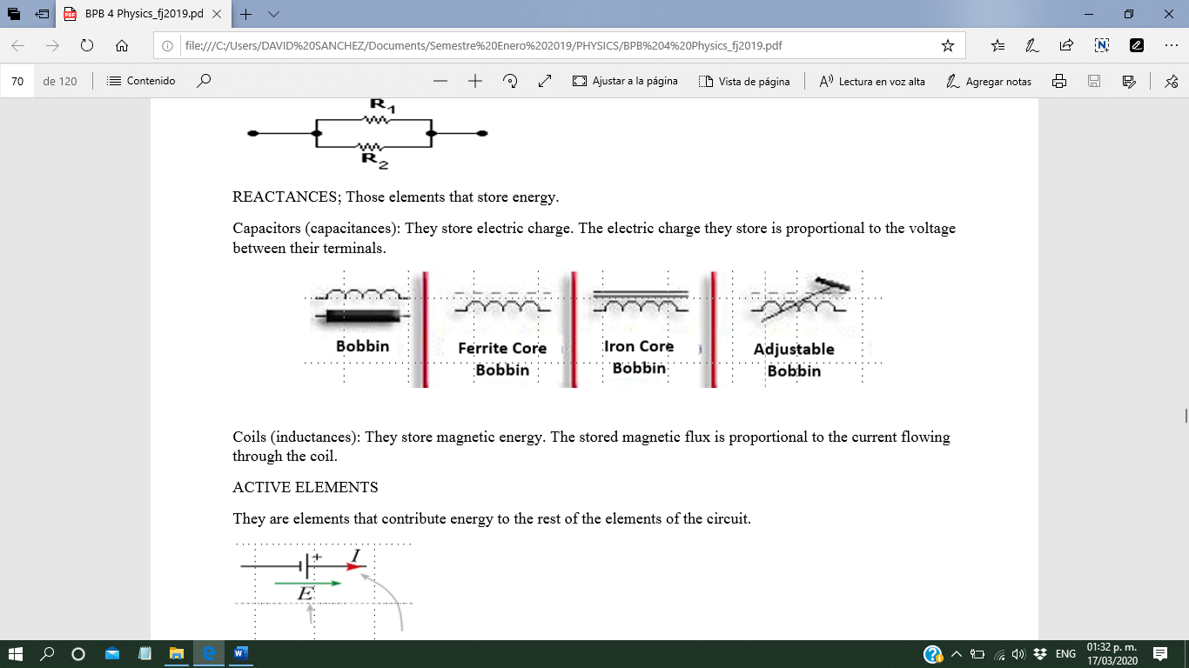Coils (inductances): They store magnetic energy. The stored magnetic flux is proportional to the current flowing through the coil.

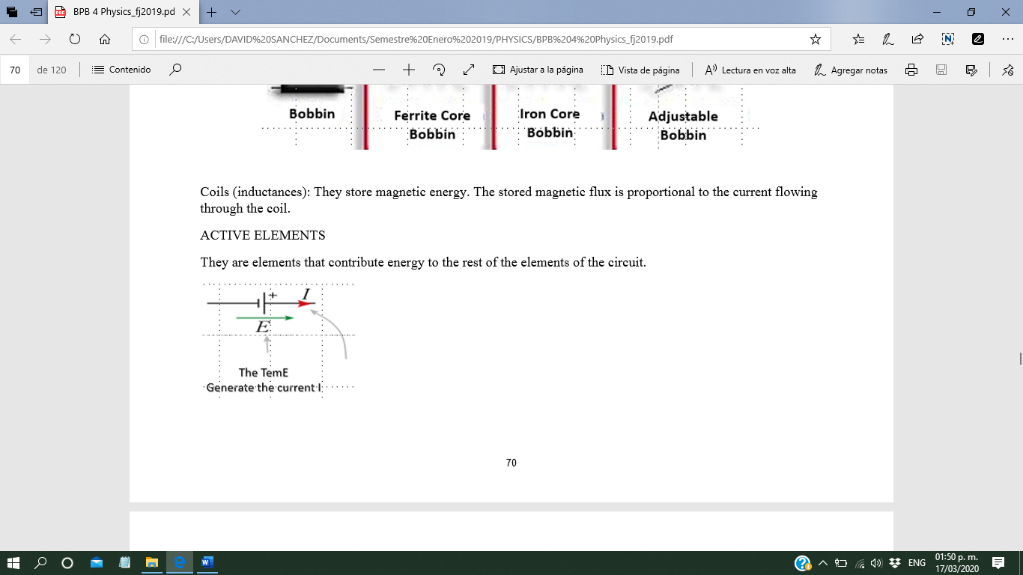ACTIVE ELEMENTS

They are elements that contribute energy to the rest of the elements of the circuit.

VOLTAGE GENERATORS They maintain the characteristics of the voltage between their terminals, independently of the elements that make up the rest of the circuit. When this does not happen, it is said to behave like a real voltage generator

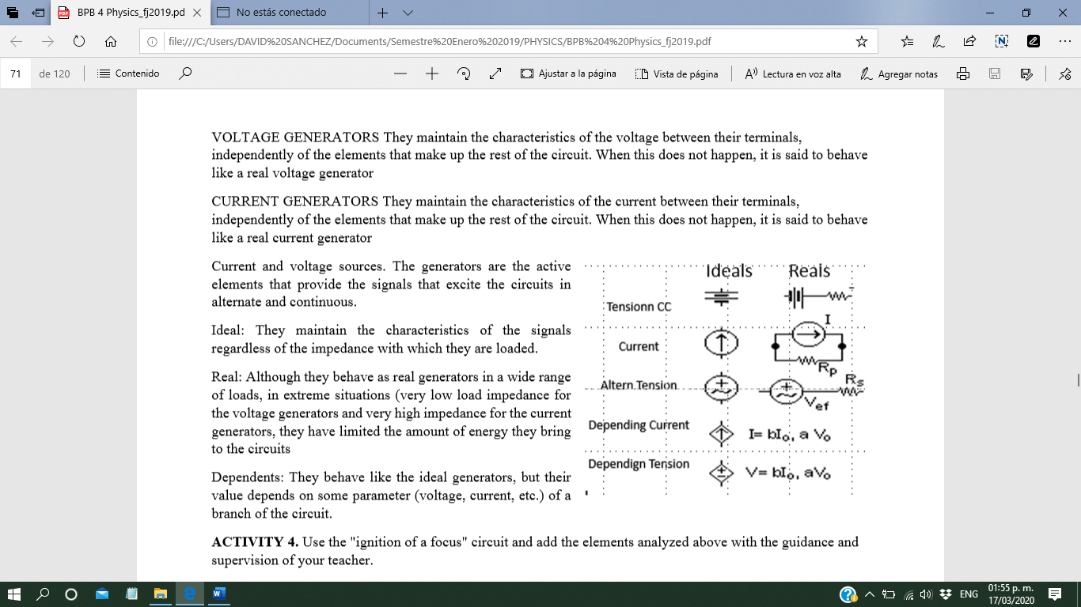CURRENT GENERATORS They maintain the characteristics of the current between their terminals, independently of the elements that make up the rest of the circuit. When this does not happen, it is said to behave like a real current generator

Current and voltage sources. The generators are the active elements that provide the signals that excite the circuits in alternate and continuous.

Ideal: They maintain the characteristics of the signals regardless of the impedance with which they are loaded.

Real: Although they behave as real generators in a wide range of loads, in extreme situations (very low load impedance for the voltage generators and very high impedance for the current generators, they have limited the amount of energy they bring to the circuits

Dependents: They behave like the ideal generators, but their value depends on some parameter (voltage, current, etc.) of a branch of the circuit.

OHM'S LAW

Ohm's Law shows the relationship that exists between a resistor, voltage or voltage in its terminals and the current that passes through it.

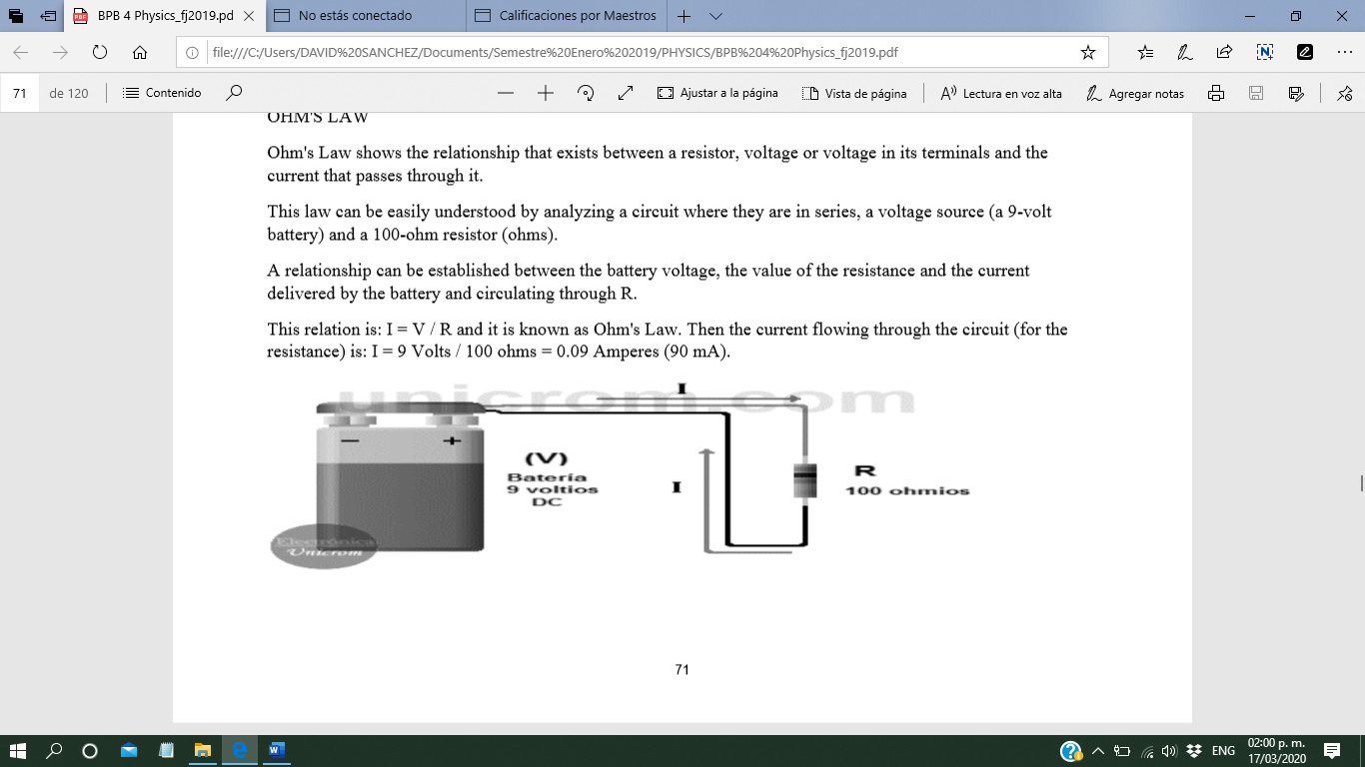This law can be easily understood by analyzing a circuit where they are in series, a voltage source (a 9-volt battery) and a 100-ohm resistor (ohms).

A relationship can be established between the battery voltage, the value of the resistance and the current delivered by the battery and circulating through R.

This relation is: I = V / R and it is known as Ohm's Law. Then the current flowing through the circuit (for the resistance) is: I = 9 Volts / 100 ohms = 0.09 Amperes (90 mA).

Ohm remains: V = I x R. Then, knowing the current and the value of the resistor, the voltage in the resistor can be obtained, like this: V = 0.09 Amps x 100 ohms = 9 Volts.

As in the previous case, if the resistance is cleared as a function of voltage and current, Ohm's Law of the form is obtained: R = V / I. Then knowing the voltage in the resistance and the current passing through it is obtained: R = 9 Volts / 0.09 Amperes = 100 ohms.

To remember the three expressions of Ohm's Law, the previous triangle is used, which has a lot of similarity with the formulas analyzed previously.

Linear relationship between current and voltage in a resistor

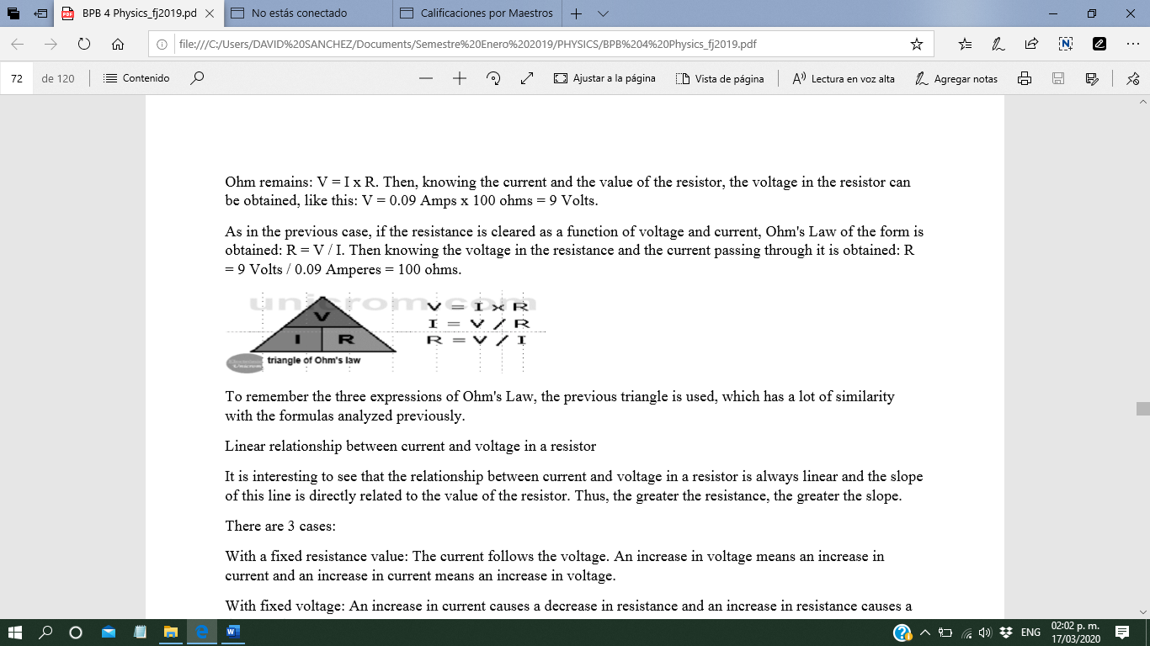It is interesting to see that the relationship between current and voltage in a resistor is always linear and the slope of this line is directly related to the value of the resistor. Thus, the greater the resistance, the greater the slope.

**There are 3 cases:**

With a fixed resistance value: The current follows the voltage. An increase in voltage means an increase in current and an increase in current means an increase in voltage.

With fixed voltage: An increase in current causes a decrease in resistance and an increase in resistance causes a decrease in current

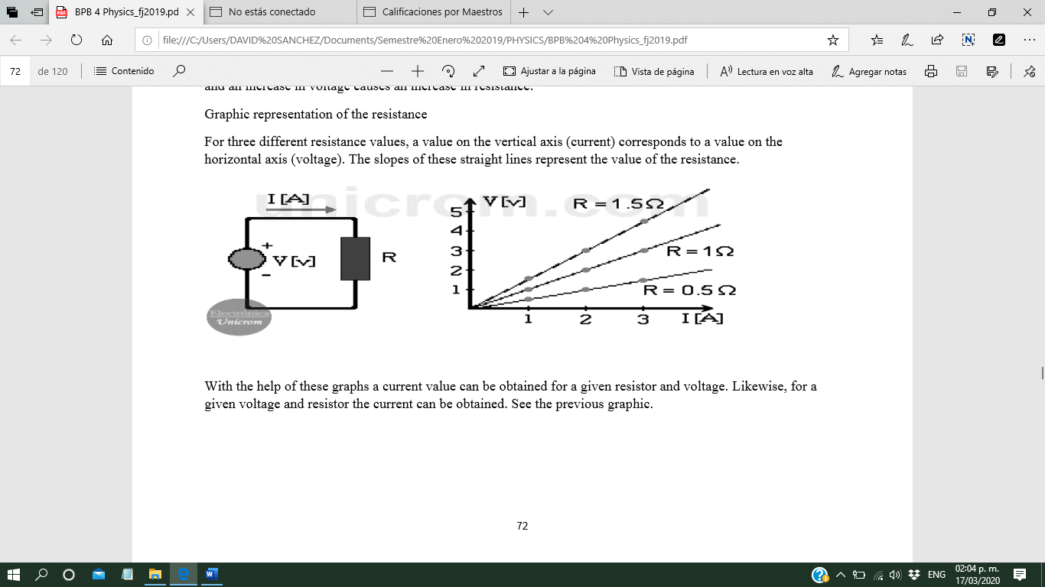With the fixed current: The voltage follows the resistance. An increase in resistance causes an increase in voltage and an increase in voltage causes an increase in resistance.

Graphic representation of the resistance

For three different resistance values, a value on the vertical axis (current) corresponds to a value on the horizontal axis (voltage). The slopes of these straight lines represent the value of the resistance.

With the help of these graphs a current value can be obtained for a given resistor and voltage. Likewise, for a given voltage and resistor the current can be obtained. See the previous graphic.

Internal resistance in voltage / voltage sources

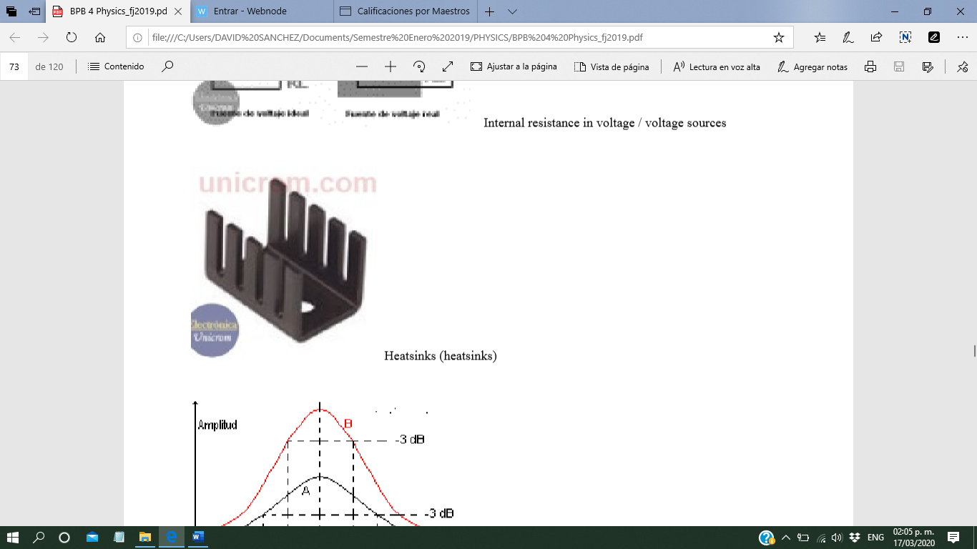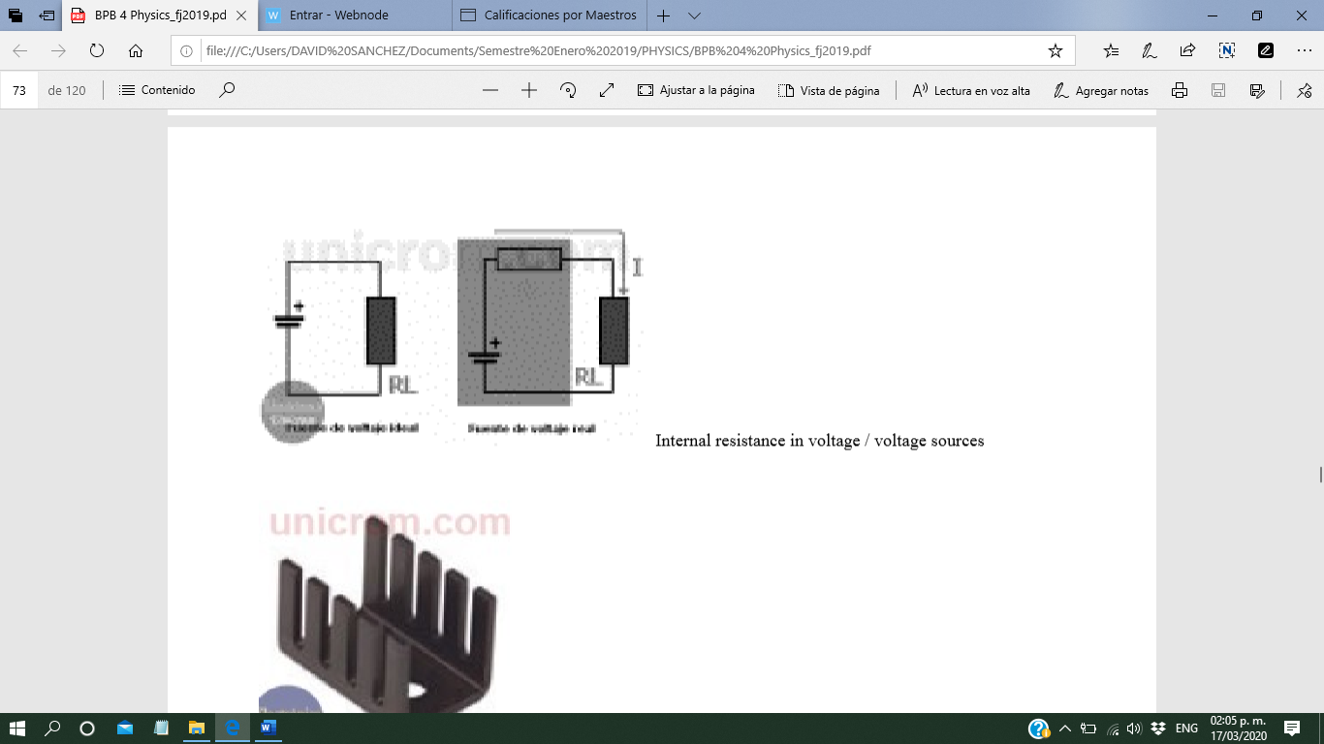

Heatsinks (heatsinks

**Clousing write in your notebook a glossary of 10 words form you can add symbols too.**