**_________________________________________________________**

**OPENING ACTIVITY 1. Answer the following questions in your notebook.**

1. How does it stay on, your cell phone, laptop, refrigerator etc?

2. Does everyone need the same type of power (batteries, contacts)?

3. What do you think this difference is due to?

4. Are there different types of electric current?

5. What is the name of what keeps electric and electronic devices on?

**DEVELOPMENT Activity 2> create a diagram in your notebook according with the theme>**

**ELECTRICITY**

**ELECTROMOTER POWER SOURCE (FEM OR VOLTAGE SOURCE).**

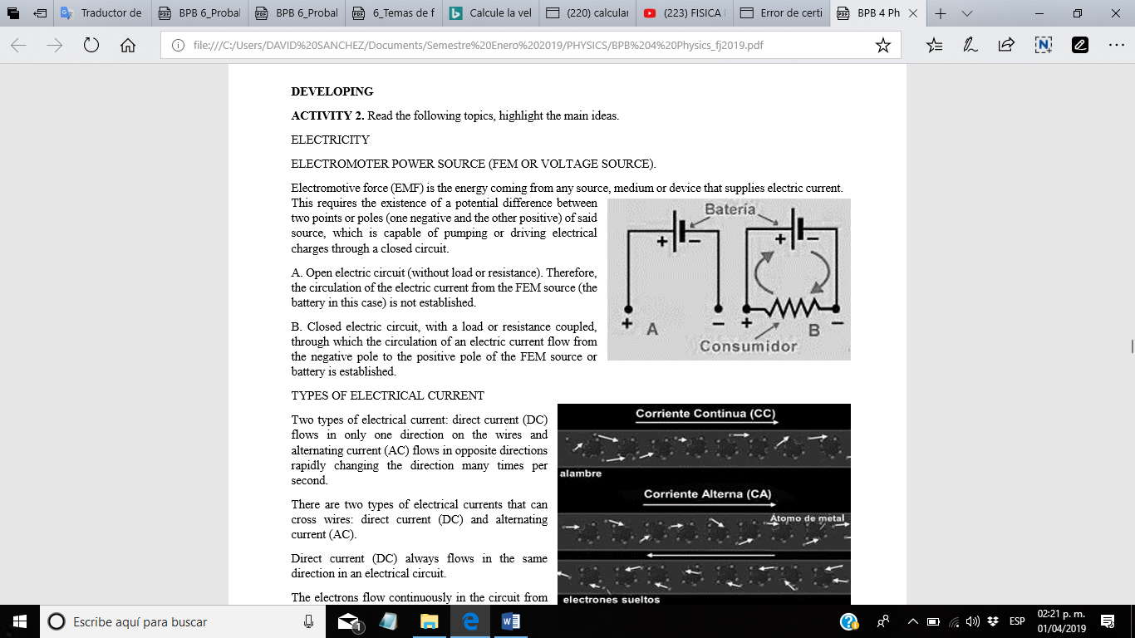Electromotive force (EMF) is the energy coming from any source, medium or device that supplies electric current. This requires the existence of a potential difference between two points or poles (one negative and the other positive) of said source, which is capable of pumping or driving electrical charges through a closed circuit.

*A. Open electric circuit (without load or resistance). Therefore, the circulation of the electric current from the FEM source (the battery in this case) is not established.*

*B. Closed electric circuit, with a load or resistance coupled, through which the circulation of an electric current flow from the negative pole to the positive pole of the FEM source or battery is established.*

TYPES OF ELECTRICAL CURRENT

Two types of electrical current: direct current (DC) flows in only one direction on the wires and alternating current (AC) flows in opposite directions rapidly changing the direction many times per second.

There are two types of electrical currents that can cross wires: direct current (DC) and alternating current (AC).

Direct current (DC) always flows in the same direction in an electrical circuit.

The electrons flow continuously in the circuit from the negative terminal of the battery to the positive terminal. Even when no current is passing through the conductor, the electrons in the wire are moving at speeds of up to 600 miles (1,000 kilometers) per second, but in random directions because the wire has a finite temperature. Since an electron is moving backward in the conductor at the same time that another is moving forward, no net charge is transported along the circuit. If a battery is connected to the ends of the wire, the electrons are forced along the conductor in the same direction.

The speed of the electrons along the conductor is less than one inch (few millimeters) per second. So a specific electron takes a long time to go around the circuit. There are so many electrons that all are continuously colliding with each other, like dominoes, and there is a net change of electric charges around the circuit that can reach the speed of light.

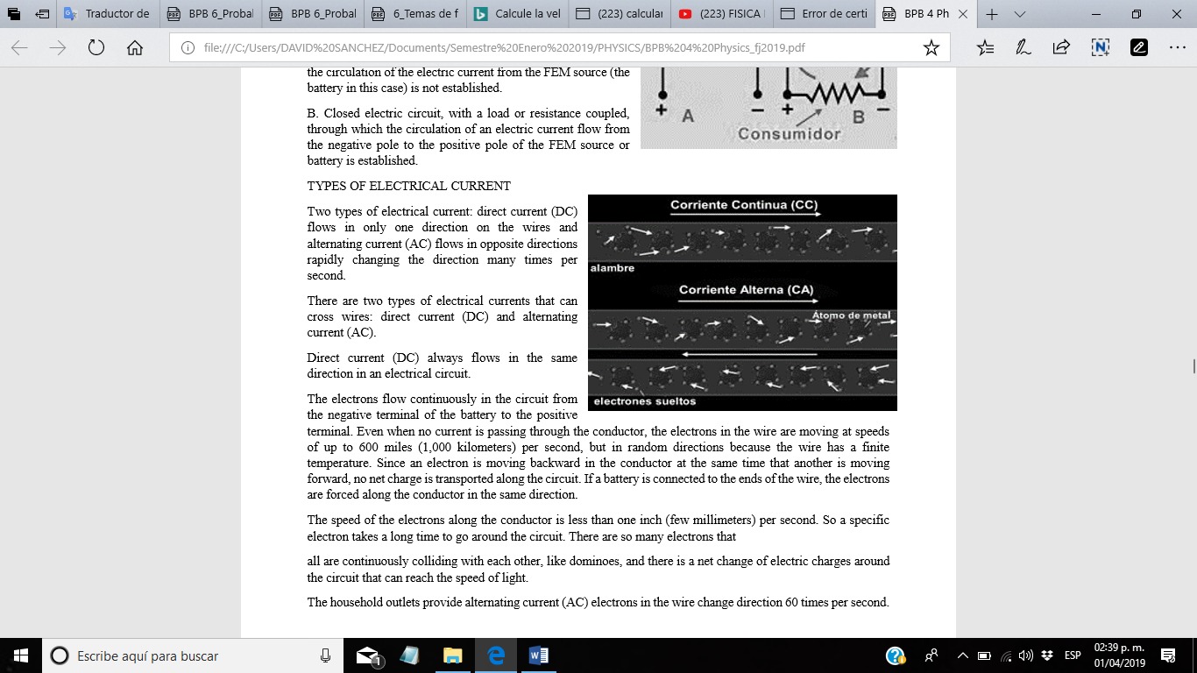The household outlets provide alternating current (AC) electrons in the wire change direction 60 times per second.

Electrical devices do not care in which direction the electrons move, since the same amount of current goes through a circuit regardless of direction of the current. The electricity distribution network that carries electricity to our homes was designed to handle alternating current.

Space weather storms can cause continuous electricity flows in the power grid. Since the network was designed to use AC electricity, and not DC electricity, direct currents induced by spatial weather conditions can damage or destroy certain equipment such as voltage transformers.

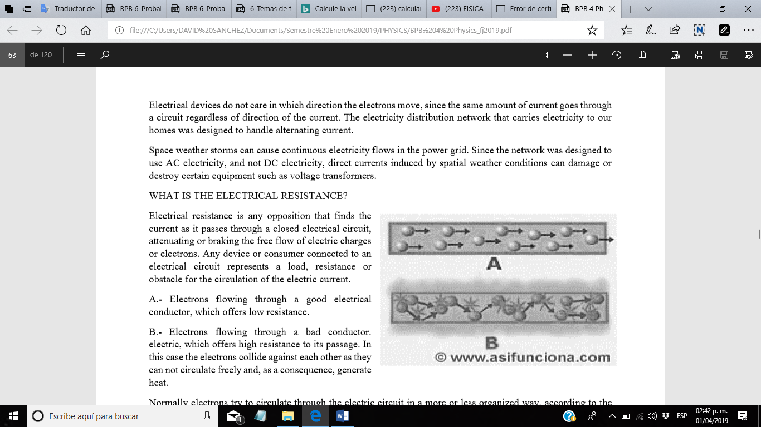**WHAT IS THE ELECTRICAL RESISTANCE?**

Electrical resistance is any opposition that finds the current as it passes through a closed electrical circuit, attenuating or braking the free flow of electric charges or electrons. Any device or consumer connected to an electrical circuit represents a load, resistance or obstacle for the circulation of the electric current.

*A.- Electrons flowing through a good electrical conductor, which offers low resistance.*

*B.- Electrons flowing through a bad conductor. electric, which offers high resistance to its passage. In this case the electrons collide against each other as they cannot circulate freely and, as a consequence, generate heat.*

Normally electrons try to circulate through the electric circuit in a more or less organized way, according to the resistance they encounter in their path.

The smaller that resistance, the greater the existing order in the microworld of electrons; but when the resistance is high, they begin to collide with each other and to release energy in the form of heat. This situation means that the temperature of the conductor always rises a little and that, in addition, it acquires higher values at the point where electrons find greater resistance to its passage.

When the material has many free electrons, as is the case with metals, it allows the passage of electrons easily and is called a conductor. Example: copper, aluminum, silver, gold, etc.

If, on the contrary, the material has few free electrons, it will not allow the passage of the current and it is called an insulator or dielectric. *Examples: ceramic, bakelite, wood (paper), plastic, etc. The main factors that determine the electrical resistance of a material are:*

*- type of material*

*- length*

*- cross section*

*- temperature*

A material can be insulator or conductor depending on its atomic configuration, and it can be better or worse conductor or insulator depending on it. The longer it has greater electrical resistance.

The longer material offers more resistance to the passage of electrical current than a shorter material. A material with a greater cross section has less resistance to the passage of electrical current than a cable with a smaller cross section. (Imagine a conductor cable cut transversely).

The direction of the current (the arrow of the current) in this case enters or leaves the page. The material with the smaller section (smaller yellow circle) offers greater resistance to current flow than the larger section.

See next graphic.

The materials that are at higher temperature have greater resistance than when they are at room temperature. See Variation of resistance with temperature. The unit of measurement of the electrical resistance is the Ohm, is represented by the Greek letter omega (Ω) and is expressed with the letter "R".

CLOUSING> Make a Illustration about how are the alternative current and continuous current.