**_________________________________________________________**

**OPENING Activity 1. Write a reflection about the knowledge about electricity including a possible explanation about the electrical potential.**

**DEVELOPMENT> Activity2 Create a comparative table in your notebook with concepts and formulas related with the theme**

**BASIC CONCEPTS OF ELECTRICAL POTENTIAL**

The notion of potential can be used in various ways. As an adjective, it refers to something that has power, virtues or power. Potential can also be a type of magnitude that indicates changes in other different magnitudes. Electric, on the other hand, is something that disposes or transmits electricity, or that manages to work thanks to it.

It is known as electrical potential to work that an electrostatic field has to carry out to mobilize a unitary positive charge from one point to another. It can be said, therefore, that the work to be determined by an external force to move a charge from one referent point to another is the electric potential.

Not be confused with that of electric potential energy, although both are related in some cases, since the latter is the energy that has a system of electric charges according to its position.

As a formula, it is indicated that the electric potential of a point X to a point Y is the work necessary to move the unit positive charge q from X to Y. Volts and joules (or joules) are the units used to express the electric potential.

It is important to consider that the concept of electric potential starts from the idea of what is known as the conservative field, where there is a force with a tendency to compensate the field strength itself so that the charged particle remains in static equilibrium. If the intention is to work with loads that are in motion, it is necessary to appeal to the potentials of ***Liénard-Wiechert.***

*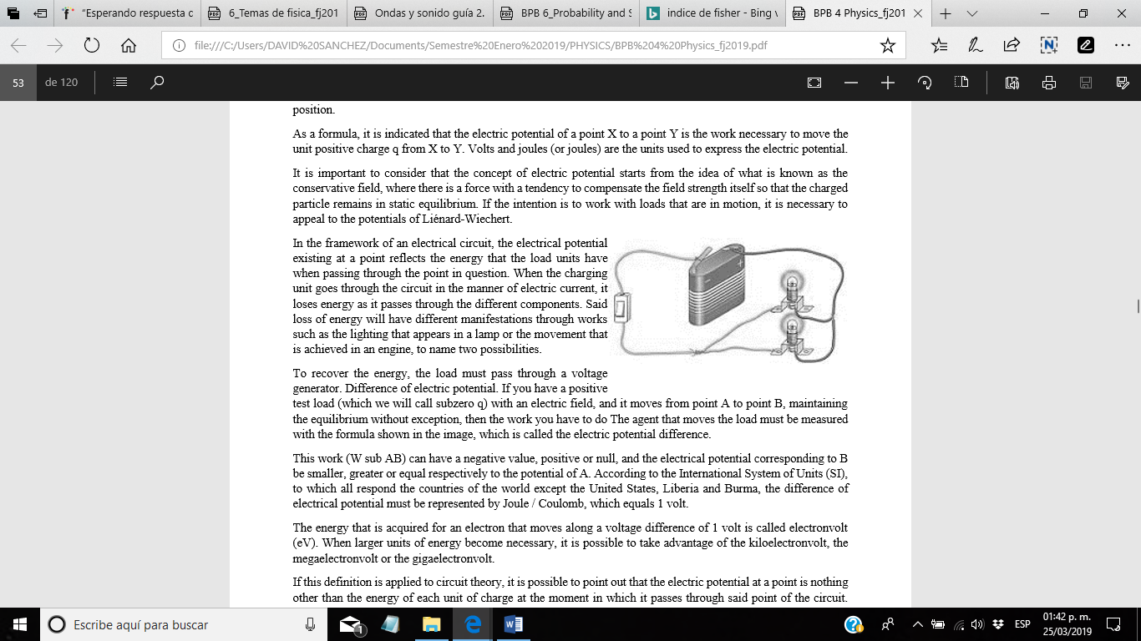In the framework of an electrical circuit, the electrical potential existing at a point reflects the energy that the load units have when passing through the point in question. When the charging unit goes through the circuit in the manner of electric current, it loses energy as it passes through the different components. Said loss of energy will have different manifestations through works such as the lighting that appears in a lamp or the movement that is achieved in an engine, to name two possibilities.*

To recover the energy, the load must pass through a voltage generator. Difference of electric potential. If you have a positive test load (which we will call subzero q) with an electric field, and it moves from point A to point B, maintaining the equilibrium without exception, then the work you have to do The agent that moves the load must be measured with the formula shown in the image, which is called the electric potential difference.

This work (W sub AB) can have a negative value, positive or null, and the electrical potential corresponding to B be smaller, greater or equal respectively to the potential of A. According to the International System of Units (SI), to which all respond the countries of the world except the United States, Liberia and Burma, the difference of electrical potential must be represented by Joule / Coulomb, which equals 1 volt.

The energy that is acquired for an electron that moves along a voltage difference of 1 volt is called electronvolt (eV). When larger units of energy become necessary, it is possible to take advantage of the kiloelectronvolt, the megaelectronvolt or the gigaelectronvolt.

If this definition is applied to circuit theory, it is possible to point out that the electric potential at a point is nothing other than the energy of each unit of charge at the moment in which it passes through said point of the circuit. Therefore, if the charging unit passes through a circuit and becomes an electric current, it loses its energy little by little.

ELECTRICAL POTENTIAL CREATED BY A PUNCTUAL LOADT

In the intensity section of the electric field, a single charge q is able to create an electric field around it.

If in this field we introduce a witness charge q 'then, according to the definition of electric potential energy of two point loads:

**V = E p q' = 0K⋅q⋅q'rq' ⇒ V = K⋅ q r**

The electric potential of the electric field created by a point charge q is obtained by means of the following expression:

**V=K⋅ q r**

where:

**V** is the electric potential at one point. In the yes. it is measured in Volts (V).

**K** is the constant of Coulomb's law. In the yes. it is measured in N · m2 / C2.

**q** hat is the point charge that creates the electric field. In the yes. it is measured in coulombs (C).

**r** is the distance between the load and the point where the potential is measured. In the yes. it is measured in meters (m).

If you look carefully at the expression you can realize that: If the charge is positive, the potential energy is positive and the electric potential V is positive. If the charge is negative, the energy is negative and the potential potential is negative. If there is no charge, the potential energy and the electric potential is zero. The electric potential does not depend on the control charge that we introduce to measure it.

**ELECTRICAL POTENTIAL CREATED BY VARIOUS POINT LOADS**

If the electric field is created by several point charges, the electric potential at a point follows the principle of superposition:

The electric potential caused by n point charges in a point of an electric field is the scalar sum of the electric potentials at that point created by each of the charges separately.

**V = V1 + V2 +...+ Vn = ∑i = 1n Vi**

Or what is the same;

**V = K⋅ (q 1 r 1 + q2r2+...+ q n r n) = K ⋅ ∑i**

Example: Two charges q1 = 3 μC and q2 = -6 μC are found in the vertices of an equilateral triangle of side 60 cm. Determine the potential at the free vertex and the potential energy that would acquire a charge q = -5 μC if it were located at that point.

Question 4 Observing the above equation, we can deduce that the intensity of the electric field can be defined with a new unit volt / meter (V / m).

Electric Potential and the Movement of Charges

**VB−VA=−W e (A→B) q**

As we saw in the topic of electrical work, the work done by an electric force to move a charge q from a point A to another B, without the presence of external forces, is a positive value. If we study what happens if the charge q is positive or negative, we obtain that:

**q<0 VB-VA>0=>VB>VA** The load moves from points of lower potential to greater potential

**lq>0 VB-VA<0=>VB<VA** It moves from points of greater potential to lower potential

Positive charges move from areas of greater electrical potential to areas of lower electrical potential.

Negative charges move from areas of lower electrical potential to areas of greater electrical potential.

Taking into account that as we studied in the section of intensity of the electric field, the positive charges move in the direction of said intensity then, the intensity of electric field is always directed from areas of greater potential to areas of lower potential.

The electric field strength always points towards decreasing potentials. 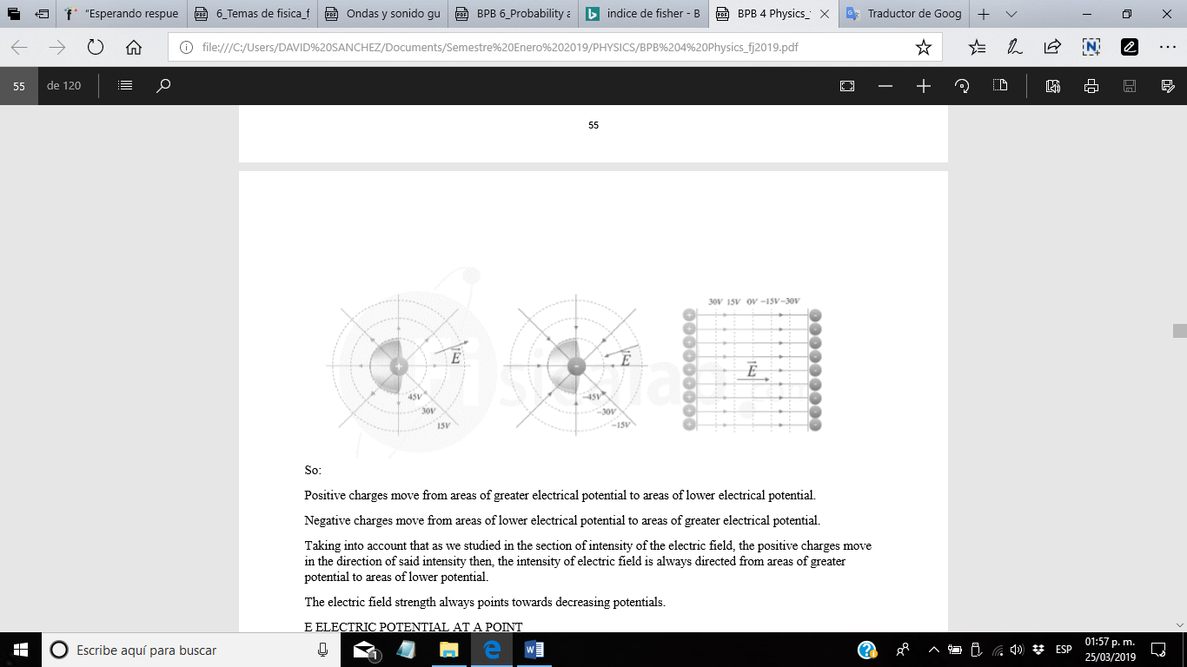

**E ELECTRIC POTENTIAL AT A POINT**

It represents the work an electric field must do to move a load between that point and another point taken as a reference or the work a force must do to move a load against the electric field, from the reference point to the point for which the potential is measured. As a point of reference many times the value of land is taken.

Normally speaking of potential difference or electrical voltage, where instead of taking a reference point two points of an electric field are taken.

|  |  |
| --- | --- |
| **DIFFERENCE OF POTENTIAL OR TENSION** The potential difference between two points A and B of an electric field is a scalar value that indicates the work that must be done to move a charge q0 from point A to point B. The unit in which the potential is measured is the volt or volt. |  |
| **Potential unit**  Being a measure of work per unit of charge, one way to define the volt is as joule / coulomb. That is to say that there is a potential difference of one volt, when to move a load coulomb between two points a joule job must be performed. |  |
| It is also possible to express the volt with other relationships, such as electrical power over electric current. In this way: |  |
| If two points between which there is a potential difference are joined by a conductor, a movement of electric charges occurs generating an electric current. |  |

**VOLTAGE /Electric tension**

Physical magnitude that drives electrons along a conductor in a closed electrical circuit. Voltage. Also called voltage or potential difference is a physical quantity that drives electrons along a conductor in a closed electrical circuit, causing the flow of an electric current.

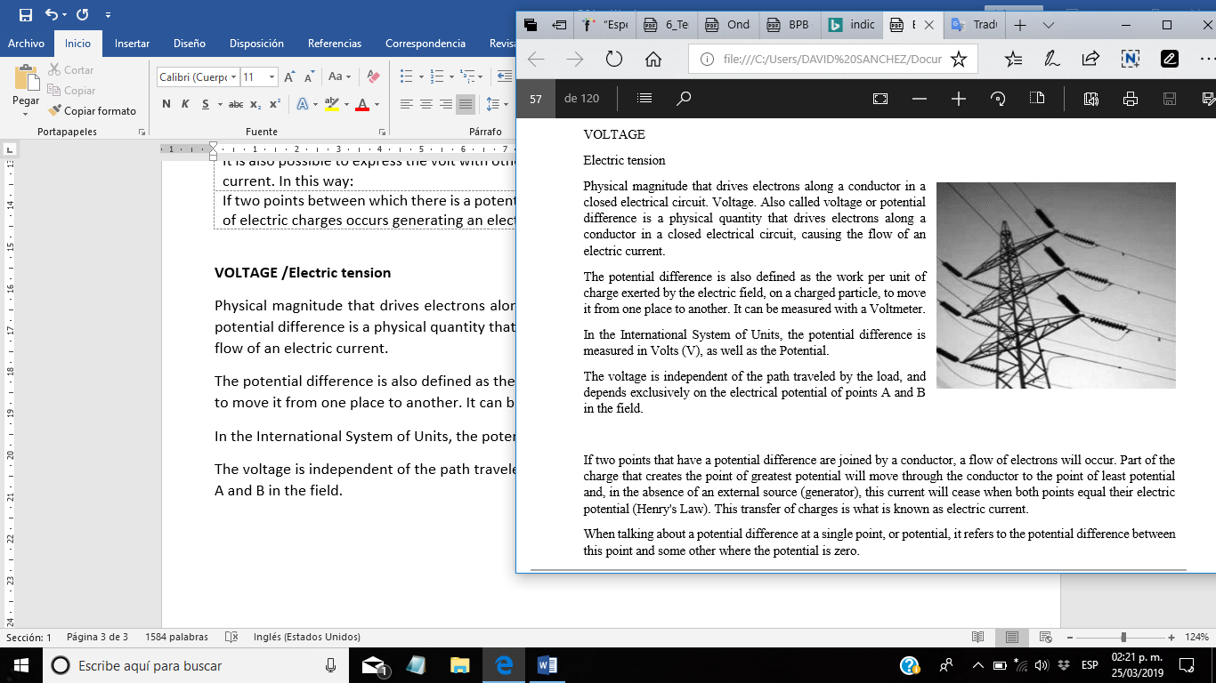The potential difference is also defined as the work per unit of charge exerted by the electric field, on a charged particle, to move it from one place to another. It can be measured with a Voltmeter.

In the International System of Units, the potential difference is measured in Volts (V), as well as the Potential.

The voltage is independent of the path traveled by the load, and depends exclusively on the electrical potential of points A and B in the field.

If two points that have a potential difference are joined by a conductor, a flow of electrons will occur. Part of the charge that creates the point of greatest potential will move through the conductor to the point of least potential and, in the 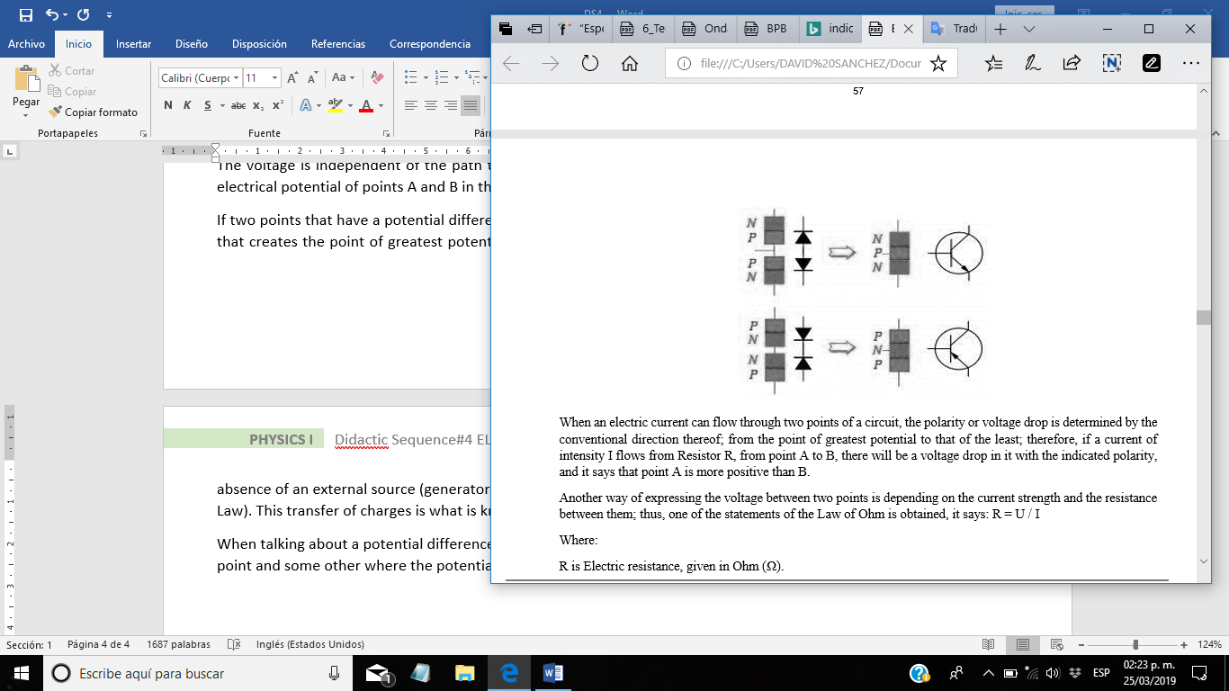absence of an external source (generator), this current will cease when both points equal their electric potential (Henry's Law). This transfer of charges is what is known as electric current.

When talking about a potential difference at a single point, or potential, it refers to the potential difference between this point and some other where the potential is zero.

When an electric current can flow through two points of a circuit, the polarity or voltage drop is determined by the conventional direction thereof; from the point of greatest potential to that of the least; therefore, if a current of intensity I flows from Resistor R, from point A to B, there will be a voltage drop in it with the indicated polarity, and it says that point A is more positive than B.

Another way of expressing the voltage between two points is depending on the current strength and the resistance between them; thus, one of the statements of the Law of Ohm is obtained, it says: **R = U / I**

*Where:*

***R*** *is Electric resistance, given in Ohm* ***(Ω).***

***V*** *is Voltage in Volt* ***(V),***

***I*** *is the electrical Intensity, given in Amperes* ***(A).***

*It is important to note that* ***(V)*** *does not refer to the electrical Potential but to the potential difference* ***(ΔV)*** *between two points.*

**ELECTRIC LOAD** If a material is removed electrons, its total electric charge will be positive (remember that it is taking away a neutral atom (no charge) negatively charged electrons. This causes the atom is no longer neutral, but has positive charge See that in this case there are 6 protons in the atom (positive charge) and 4 electrons (negative charge) In conclusion, the total charge is positive

If the material now increases electrons (it now has more than it has when the atom is neutral), its total charge will be negative. See that in this case there are 6 protons (positive charge) and 8 electrons (negative charge) in the atom. In conclusion, the total load is negative.

If you have two materials with different levels or types of charge, then it is said that there is a potential difference between them.

In order to be able to load the materials in some way, it is necessary to apply energy to the atom.

*There are several methods to achieve it:*

*- by rubbing - by pressure - by heat - by magnetism - by a chemical action*

**POTENTIAL DIFFERENCE**

To get a lamp to turn on, an electric current must circulate through the cables to which it is connected.

For this current to circulate through the wires there must be a force called electromotive force source or to better understand, a voltage source a battery (in the case of direct current), which is simply a voltage source, which has a volt unit 1 kilovolt = 1000 volts (volts) 1 millivolt = 1/1000 = 0.001 volts (volts).

Energy is the ability to perform work and potential energy is the energy that is associated to a body by the position it has. (in our case it is the height of the cataract)

Two possible cases:

**a)** A source that delivers a high voltage with little current. The case of a very high water fall with little flow (little water current).

**b)** A source that delivers a small voltage but a lot of current. The case of a small water fall with a lot of flow (a lot of water flow).

An interesting case is one in which the source has a high voltage value and delivers a lot of current. This case would occur in a very high water fall with a very large flow. This case in particular tells us that we have a voltage source with a large power delivery capacity. Remember the power formula:

Power = Voltage x Current = V x I

**DEFINITION OF VOLTIO.**

Voltic is the name given to a derived unit that is part of the International System and that is used to express the electrical potential, the electrical voltage and the electromotive force. The word voltio comes from Volta, the surname of the physicist who invented the electric battery: Alessandro Volta (1745-1827).

A volt is equivalent to the potential difference that is registered between two points of a given conductor when, to carry from one point to another a charge of a coulomb, it is necessary to carry out the work of a July.

The electrical potential is the work that an electrostatic field needs to carry a positive charge between two points. A coulomb is a unit of measurement linked to the amount of electric charge that a certain current carry in a second. One July, on the other hand, is a unit that refers to the work that is required to transport an electric charge from a coulomb.

Keep in mind that when two points with a potential difference are linked through a conductor, a flow of electrons is generated. This process of moving loads is what we know as electric current.

The volts allow to quantify that difference of potential or electrical tension that takes place.

The electricity of the houses, in most of the South American countries, has a value of 220 volts (or 220 V, since V is the symbol of volt), while in North America it is 120 V. The cars, for Generally, they use 12V electricity.

It should be noted that the amount of volts can be named as voltage. On the other hand, we find the standard volt, which we can define as the voltage that is needed to generate, in a Josephson oscillator, a frequency of 483 597.9 GHz. This oscillator has a more stable oscillation frequency than normal, and it is defined in the formula f = 2eΔV / h, where e represents the charge of the electron, and h is the Planck constant.

This last concept, which is also known as the Josephson effect, appears when between two superconductors that are separated an electric current takes place by tunneling, that is, when the particles penetrate an impedance barrier or potential that exceeds its own kinetic energy.

In the standard volt, the relationship between voltage and frequency by means of the union depends exclusively on e and h, the fundamental constants. The frequency of a microvolt applied to said joint is 483.6 MHz.

It is worth mentioning that many people often confuse the concepts "voltio" and "vatio". The latter term is defined as a magnitude of power, just as in automobiles it is spoken of horsepower; A common mistake is to consider it a magnitude of energy, and this is seen in conversations about the consumption of electricity in the home.

**CLOUSING Activity 3 make a reflection answering to the next question to help.**

1. What do you know about the subject?

2. What did I learn in developing the sequence?

3. How can I apply it in my context?

4. Write a conclusion.