**Name: _________________________________________________________**

**OPENING Activity 1. Answer the following questions individually in your notebook.**

1) What is a biological process?

2) What is electricity?

3) What are the biological processes in which electricity is involved?

4) Based on the previous question, write 3 examples of them

5) How can a body be electrically charged?

**DEVELOPMENT Activity 2 analyze the topic and make a resume according with the electricity in living beings.**

**Electricity in Living Beings**

In the living beings and membranes of their nerve and muscle cells there are electrical potentials because they are excitable and capable of generating electrochemical impulses to transmit, the rest and action potential, by means of electrically charged ions through ion channels or polarized membrane proteins. cellular, transporting ions and molecules by passive diffusion, facilitated or active transport, that ability to have two poles with different characteristics, allow the generation of the Nervous Impulse and the transport of information through nerves and muscles by means of electrolytic substances such as Sodium = Na and Potassium K when going through the cell membrane, in the Rest Potential impulses are not transmitted by the neurons.

The Action Potential is the transmission of the impulses through the neuron, changing the intracellular and extracellular concentrations of Na, and K, Ca, the membrane potentials are given by the permeability of the ion channels or transmission sites of the cells. impulses that in the nerve cells, constitute the dendrites and axons in the neurons, these ion channels for the action potential are specific and sensitive to voltage, that is, they can deactivate or activate them.

According to the concentrations of the electrolytes or conductors of electricity, which must be for most of the extracellular sodium and for potassium, mostly intracellular, under normal conditions and during the resting period both have positive electric charges that yield to the environment where they are; But in reality, the extracellular space has a positive charge, due to the positivity of Na, but the intracellular space has a negative charge because there is greater extracellular Na than intracellular K, although this is also positive.

That is, there are many more positive charges outside the cell; In addition, intracellular proteins present negative electric charges, which means that there are less positive charges intracellularly outside the cell or extracellularly, to the extent that the intracellular space is considered negative and these intracellular and extracellular charges give the membrane a polarity , positive in its extracellular face and negative in its intracellular face, in addition they give charge called membrane potential, which is -90 milli Volts, in the resting state.

In order for the action potential to be carried out, the cellular membrane of the neuron or muscle fiber must be excited electrically, so that the sodium channels become thousands of times more permeable than normal, and the diffusion of this into the interior of the membrane is very large.

This input of positive charges takes away the polarity of the membrane since both sides of it are positive, this phase is called depolarization. This depolarization leads to the membrane potential at +40 mV in less than one millisecond. This membrane charge causes the Na channels to close, and the K channels are permeabilized, causing it to diffuse to the outside of the cell and creating a membrane potential of close to -100 mV which is then stabilized at -90 mV. Now, the ions are exchanged, that is, the Na mostly in, and the K mostly out.

The mechanism that is responsible for returning these ions to their original sites is the ATPase, vulgarly called sodium and potassium pump. This membrane protein requires ATP to exchange the ions, for every two K-ions that enter, three Na exit. This returns his mostly positive state to the extracellular space.

During one impulse and another there is a refractory period, in which there can be no other nervous impulse. The duration of that period is 1/2500 seconds, that is, in a second there may be 2,500 nerve impulses or action potentials. When Na ions flow into the cell, they trigger the same cycle at the adjacent cell site and thus the impulse is transmitted along the entire axon.

here are four very important points that must be borne in mind: The action potential does not diminish along the nerve or muscle fibers, since the action potential is an all-or-nothing phenomenon, that is, if the threshold is not reached, the Action Potential does not occur, once passed through a part of the axon or muscle fiber, the action potential can not be reactivated by a refractory period; and the increase of the stimulus does not increase the potential, but increases the frequency of the impulses.

The myelin sheath, which functions as an insulator, coils in a spiral around the Schwann cell and in turn surrounds the nerve fiber. Its function is to increase the speed of nerve impulse through fiber. The myelin sheath does not have a uniform continuity, it is segmented along the fiber; the spaces between those segments, are Ranvier's node. In small unmyelinated fibers, the action potential has a velocity of 0.25 m / s. In the large myelinated fibers, they are transmitted at a speed of 100 m / s.

**HOW DO ELECTRIC EYELIDS PRODUCE ELECTRICITY?**

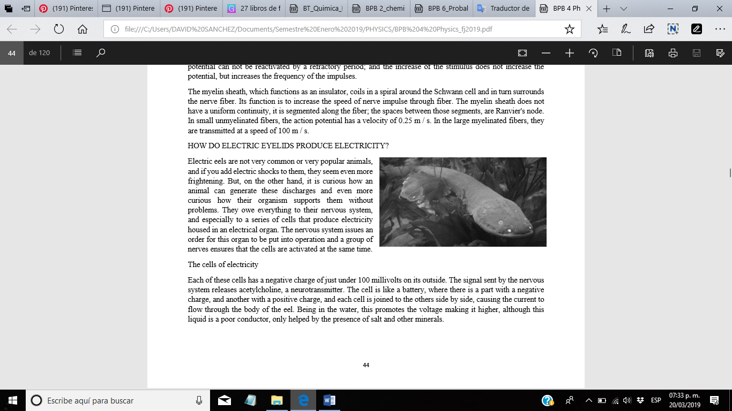Electric eels are not very common or very popular animals, and if you add electric shocks to them, they seem even more frightening. But, on the other hand, it is curious how an animal can generate these discharges and even more curious how their organism supports them without problems. They owe everything to their nervous system, and especially to a series of cells that produce electricity housed in an electrical organ. The nervous system issues an order for this organ to be put into operation and a group of nerves ensures that the cells are activated at the same time.

**The cells of electricity**

Each of these cells has a negative charge of just under 100 millivolts on its outside. The signal sent by the nervous system releases acetylcholine, a neurotransmitter. The cell is like a battery, where there is a part with a negative charge, and another with a positive charge, and each cell is joined to the others side by side, causing the current to flow through the body of the eel. Being in the water, this promotes the voltage making it higher, although this liquid is a poor conductor, only helped by the presence of salt and other minerals.

Like other animals, electricity is mostly used to create fields of electricity, and to feel prey when distorted. If someone gets in his way, the eel will notice because something will not be good with the electrical energy of the environment generated by it.

**How do they not electrocute themselves?**

Although there is no clear answer to this question, it is possible that to cause damage the current must pass with a certain intensity and duration for a part of the body. The eel, with a size similar to that of a human arm, requires that the current pass through 50 seconds to be damaged. In this case, the current has less intensity and time, passing only 2 seconds.

Much of the electricity dissipates in the water through the skin and is reduced with the central nervous system and the heart. Although the electricity that reaches its prey is a small part of what it produces, it is stronger than what it receives in its own body. This also indicates that probably a part of the energy effectively hits them with force, due to the movements that we can see that it does when it generates a discharge. However, she is adapted to pain, and she does not suffer too much about it.

|  |
| --- |
| **Answer the following questions individually and comment on their answers in plenary.** |
| 1. Based on what you have read, do you consider that within the biological processes there is electricity? Why? |
| 1. Is the electric energy present in the vital processes of the human being? |
| 1. in which? |
| 1. What is electric charge? |

**ELECTRIC CHARGE**

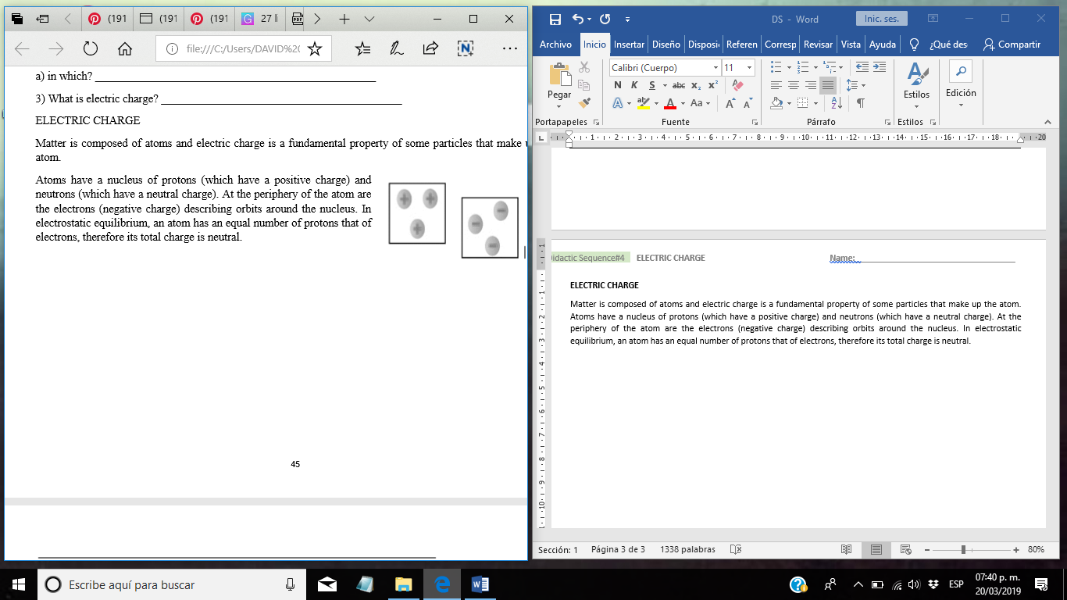Matter is composed of atoms and electric charge is a fundamental property of some particles that make up the atom. Atoms have a nucleus of protons (which have a positive charge) and neutrons (which have a neutral charge). At the periphery of the atom are the electrons (negative charge) describing orbits around the nucleus. In electrostatic equilibrium, an atom has an equal number of protons that of electrons, therefore its total charge is neutral.

The electrons of the most distant orbits (free electrons) can leave the atom and be added to another nearby. The atom that has one less electron is positively charged, while the atom that gained an electron has a negative charge. Atoms or charged matter of the same sign are rejected, whereas when their sign is opposite, a force of attraction appears. In the same way we can say that a material is electrically charged if its atoms gave or accepted electrons.

For example, when rubbing two different materials such as plastic and glass occurs with many of their atoms, they release and accept electrons, therefore, one of the materials is positively charged (their atoms released electrons) and the other negatively (with more electrons).

**LAW OF CONSERVATION OF THE CARGO**

The law of conservation of charges says that given an isolated system there are no charges that are created or destroyed, but the charge is conserved.

**ELECTRIC LOAD UNITS**

In the International System the electric charge is measured in coulomb.

*A coulomb is a large load unit so it is common to use submultiples like the micro coulomb*:

*The electric charge of an electron is approximately*

*The electrical charge of a material is always a multiple of the electric charge of an electron.*

|  |
| --- |
| **Clearly answer the following and in group perform feedback with teacher support** |
| *Define the concept of "electric charge"* |
| *How much charge do 1000 electrons have?* |
| *How many electrons are in* |
| *In a car battery or a dry battery, how do you know that they are correctly installed in the device where they will be used?* |
| *Do you consider that a body can be charged electrically? how? why?* |

*ELECTRIZATION*

*What is electrization? When a body is endowed with electrical properties, that is, it acquires electrical charges, it is said to have been electrified.*

*Electrification is one of the phenomena studied by electrostatics. To explain how static electricity originates, we must consider that matter is made up of atoms, and atoms of charged particles, a nucleus surrounded by a cloud of electrons. Normally, the matter is neutral (not electrified), has the same number of positive and negative charges.*

*Some atoms have more facility to lose their electrons than others. If a material tends to lose some of its electrons when it comes in contact with another, it is said to be more positive in the Triboelectric series. If a material tends to capture electrons when it comes in contact with another material, this material is more negative in the triboelectric series. An example of materials ordered from most positive to most negative is:*

*Rabbit skin, Glass, human hair, nylon, wool, silk, paper, cotton, wood, amber, polyester, polyurethane, vinyl (PVC), Teflon.*

The glass rubbed with silk causes a separation of the charges because both materials occupy different positions in the triboelectric series, the same can be said of amber and glass. When two non-conductive materials come into contact, one of the materials can capture electrons from the other material. The amount of charge depends on the nature of the materials (their separation in the triboelectric series), and the area of the surface that comes into contact. Another factor that intervenes is the state of the surfaces, if they are smooth or rough (then, the contact surface is small).

The humidity or impurities that contain the surfaces provide a way for the charges to be recombined. The presence of impurities in the air has the same effect as humidity.

In school we have rubbed the pen with our clothes and we have seen how it attracts pieces of paper. In the classroom experiences, various materials are rubbed, glass with silk, leather, etc.

Elbow balls electrified are used to show the two classes of charges and their interactions.

**From these experiments it is concluded that:**

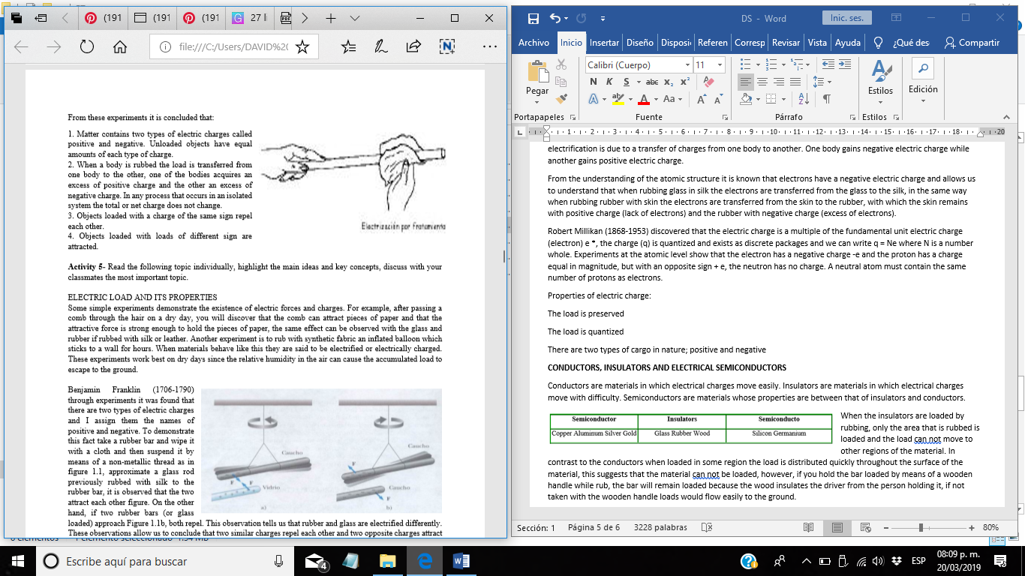1. Matter contains two types of electric charges called positive and negative. Unloaded objects have equal amounts of each type of charge. 2. When a body is rubbed the load is transferred from one body to the other, one of the bodies acquires an excess of positive charge and the other an excess of negative charge. In any process that occurs in an isolated system the total or net charge does not change. 3. Objects loaded with a charge of the same sign repel each other. 4. Objects loaded with loads of different sign are attracted.

ELECTRIC LOAD AND ITS PROPERTIES Some simple experiments demonstrate the existence of electric forces and charges. For example, after passing a comb through the hair on a dry day, you will discover that the comb can attract pieces of paper and that the attractive force is strong enough to hold the pieces of paper, the same effect can be observed with the glass and rubber if rubbed with silk or leather. Another experiment is to rub with synthetic fabric an inflated balloon which sticks to a wall for hours. When materials behave like this they are said to be electrified or electrically charged. These experiments work best on dry days since the relative humidity in the air can cause the accumulated load to escape to the ground.

**Benjamin Franklin** (1706-1790) through experiments it was found that there are two types of electric charges and I assign them the names of positive and negative. To demonstrate this fact take a rubber bar and wipe it with a cloth and then suspend it by means of a non-metallic thread as in figure 1.1, approximate a glass rod previously rubbed with silk to the rubber bar, it is observed that the two attract each other figure. On the other hand, if two rubber bars (or glass loaded) approach Figure 1.1b, both repel. This observation tells us that rubber and glass are electrified differently. These observations allow us to conclude that two similar charges repel each other and two opposite charges attract each other.

This is understood from the fact that the neutral matter, without charge, contains positive and negative electric charges. The electric charge on a glass bar is called positive (+). Any body that is repelled by the glass bar must have a positive charge, any body that is attracted will have a negative charge. The load on a rubber bar is called negative (-), and any body that is attracted to a rubber bar must have positive charge, any body that is repelled will have a negative charge.

The electric charges of attraction are responsible for the behavior of commercial products

For example;

The plastic in contact lenses (etafilocom) which is made of molecules that attract electrically the protein molecules in human tears, which are absorbed and held by the plastic in such a way that the lenses at the end are formed of tears human, in this way the eye does not perceive the lens as a foreign object.

Many cosmetics use this advantage of electric forces when they incorporate materials that are electrically attracted to the skin or hair allowing them to remain in place once applied.

The electric charge is always conserved, when one body is rubbed with another, no charge is created in the process, the electrification is due to a transfer of charges from one body to another. One body gains negative electric charge while another gains positive electric charge.

From the understanding of the atomic structure it is known that electrons have a negative electric charge and allows us to understand that when rubbing glass in silk the electrons are transferred from the glass to the silk, in the same way when rubbing rubber with skin the electrons are transferred from the skin to the rubber, with which the skin remains with positive charge (lack of electrons) and the rubber with negative charge (excess of electrons).

Robert Millikan (1868-1953) discovered that the electric charge is a multiple of the fundamental unit electric charge (electron) e *, the charge (q) is quantized and exists as discrete packages and we can write q = Ne where N is a number whole. Experiments at the atomic level show that the electron has a negative charge -e and the proton has a charge equal in magnitude, but with an opposite sign + e, the neutron has no charge. A neutral atom must contain the same number of protons as electrons.

Properties of electric charge:

The load is preserved

The load is quantized

There are two types of cargo in nature; positive and negative

**CONDUCTORS, INSULATORS AND ELECTRICAL SEMICONDUCTORS**

Conductors are materials in which electrical charges move easily. Insulators are materials in which electrical charges move with difficulty. Semiconductors are materials whose properties are between that of insulators and conductors.

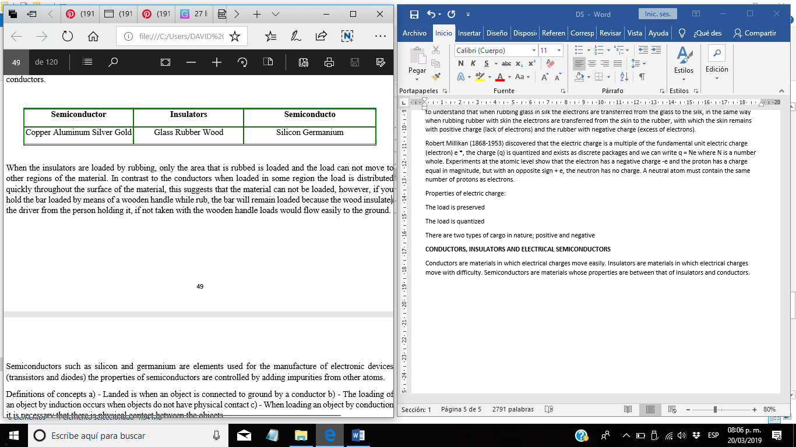When the insulators are loaded by rubbing, only the area that is rubbed is loaded and the load can not move to other regions of the material. In contrast to the conductors when loaded in some region the load is distributed quickly throughout the surface of the material, this suggests that the material can not be loaded, however, if you hold the bar loaded by means of a wooden handle while rub, the bar will remain loaded because the wood insulates the driver from the person holding it, if not taken with the wooden handle loads would flow easily to the ground.

Semiconductors such as silicon and germanium are elements used for the manufacture of electronic devices (transistors and diodes) the properties of semiconductors are controlled by adding impurities from other atoms.

**Landed** is when an object is connected to ground by a conductor b) - The loading of an object by induction occurs when objects do not have physical contact c) - When loading an object by conduction it is necessary that there is physical contact between the objects.

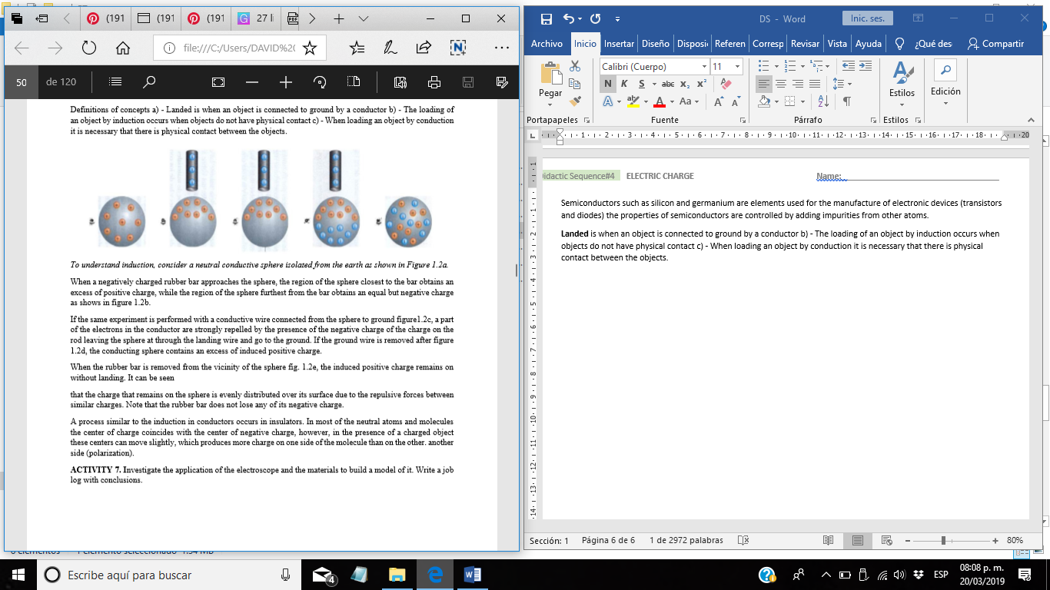To understand induction, consider a neutral conductive sphere isolated from the earth as shown in Figure 1.2a.

When a negatively charged rubber bar approaches the sphere, the region of the sphere closest to the bar obtains an excess of positive charge, while the region of the sphere furthest from the bar obtains an equal but negative charge as shows in figure 1.2b.

If the same experiment is performed with a conductive wire connected from the sphere to ground figure1.2c, a part of the electrons in the conductor are strongly repelled by the presence of the negative charge of the charge on the rod leaving the sphere at through the landing wire and go to the ground. If the ground wire is removed after figure 1.2d, the conducting sphere contains an excess of induced positive charge.

When the rubber bar is removed from the vicinity of the sphere fig. 1.2e, the induced positive charge remains on without landing. It can be seen

that the charge that remains on the sphere is evenly distributed over its surface due to the repulsive forces between similar charges. Note that the rubber bar does not lose any of its negative charge.

A process similar to the induction in conductors occurs in insulators. In most of the neutral atoms and molecules the center of charge coincides with the center of negative charge, however, in the presence of a charged object these centers can move slightly, which produces more charge on one side of the molecule than on the other. another side (polarization).

CLOUSING Activity 3 make a mental map in your notebook related with electricity.